Equatorial Great Circle
# Source: AI Source: Provided by: [Data Path: Persons Table -> ID Column: 1, Name_En Column: Motasem Essam] -> From: [ChatGPT] on [7/25/2026]
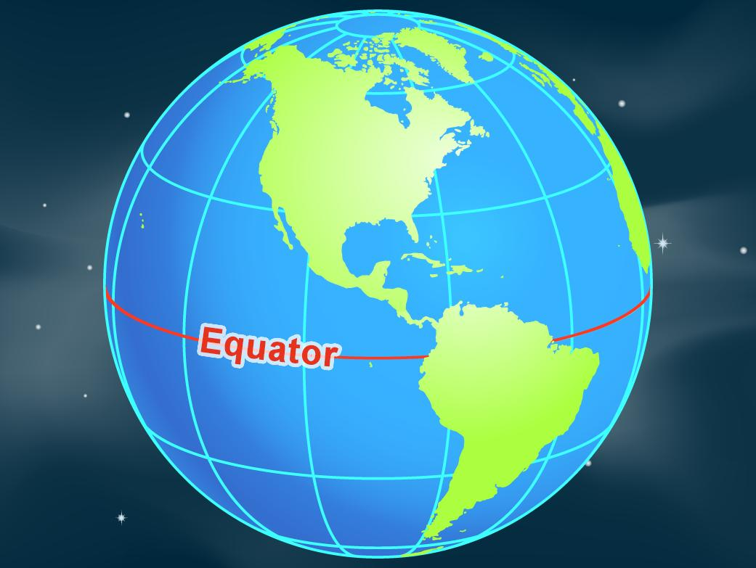
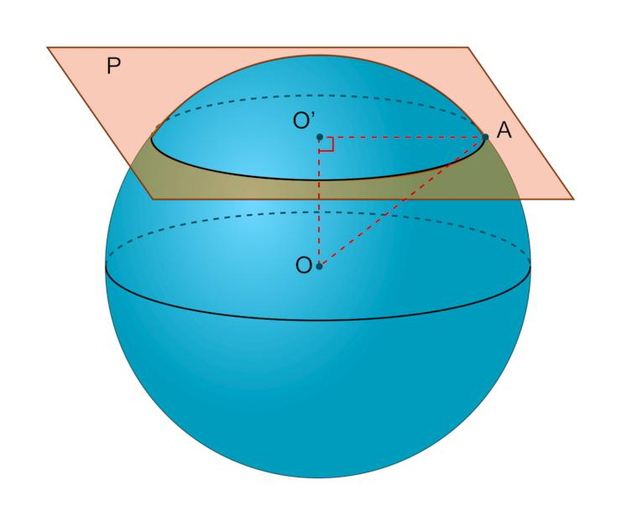
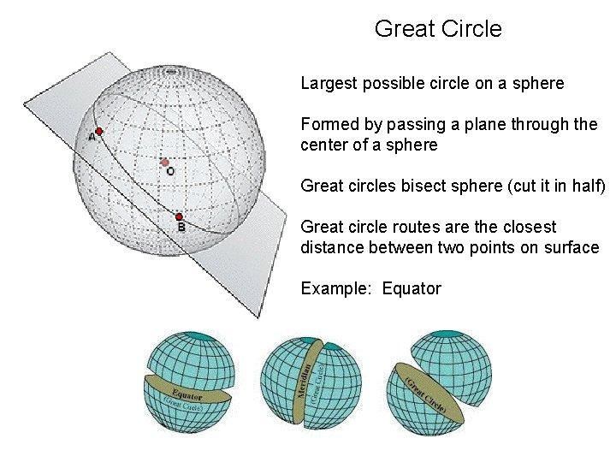

Definition
# Source: AI Source: Provided by: [Data Path: Persons Table -> ID Column: 1, Name_En Column: Motasem Essam] -> From: [ChatGPT] on [7/25/2026]
An equatorial great circle is a great circle that lies in the equatorial plane of a sphere or spherical body. This plane passes through the sphere's center and is perpendicular to its chosen rotational axis.
For Earth, the Equator is the great circle halfway between the North Pole and South Pole. It divides Earth into the Northern and Southern Hemispheres.
More generally, on a sphere without a specified rotational axis, the term equatorial great circle requires a chosen axis or reference orientation.

Simple Definition
# Source: AI Source: Provided by: [Data Path: Persons Table -> ID Column: 1, Name_En Column: Motasem Essam] -> From: [ChatGPT] on [7/25/2026]
An equatorial great circle is a circle around the middle of a sphere, formed by cutting the sphere with a plane through its center perpendicular to its chosen axis.
For Earth, this circle is the Equator.

Geometric Representation
# Source: AI Source: Provided by: [Data Path: Persons Table -> ID Column: 1, Name_En Column: Motasem Essam] -> From: [ChatGPT] on [7/25/2026]
An equatorial great circle is defined by three main geometric elements:
- Center: $O$, the center of the sphere.
- Equatorial plane: A plane passing through $O$ and perpendicular to the chosen axis.
- Equatorial great circle: The intersection of that plane with the sphere's surface.
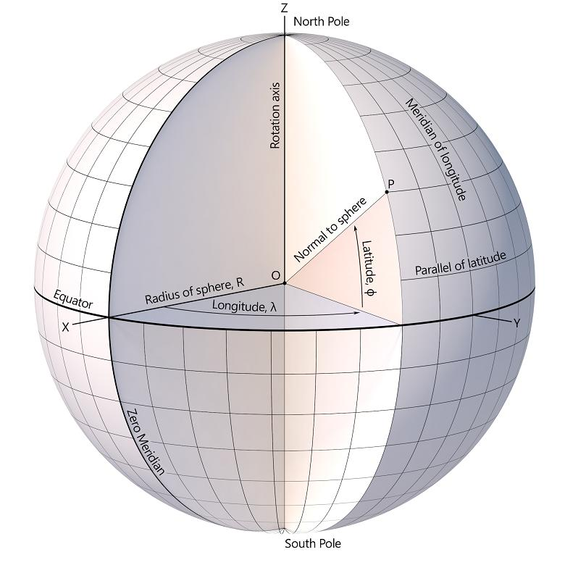
For a sphere centered at the origin, if the rotational axis is the $z$-axis, the equatorial plane is the $xy$-plane.

Mathematical Representation
# Source: AI Source: Provided by: [Data Path: Persons Table -> ID Column: 1, Name_En Column: Motasem Essam] -> From: [ChatGPT] on [7/25/2026]
Consider a sphere of radius $R$ centered at the origin.
The sphere's equation is
$$x^{2}+y^{2}+z^{2}=R^{2}$$
The equatorial plane is
$$z=0$$
Substituting $z=0$ into the sphere equation gives
$$\boxed{x^{2}+y^{2}=R^{2}, z=0}$$
This represents the equatorial great circle.

Important formulas
# Source: AI Source: Provided by: [Data Path: Persons Table -> ID Column: 1, Name_En Column: Motasem Essam] -> From: [ChatGPT] on [7/25/2026]
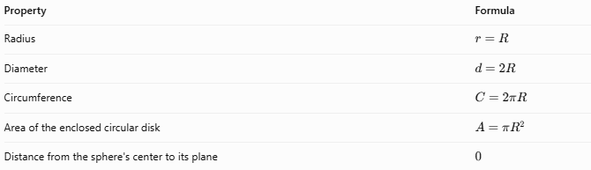
Property | Formula
Radius | $$r=R$$
Diameter | $$d=2R$$
Circumference | $$C=2πR$$
Area of the enclosed circular disk | $$A=πR^{2}$$
Distance from the sphere's center to its plane | \(0\)
The area $A=πR^{2}$ refers to the flat disk enclosed by the circle, not the curved surface area of the sphere.

Key Characteristics
# Source: AI Source: Provided by: [Data Path: Persons Table -> ID Column: 1, Name_En Column: Motasem Essam] -> From: [ChatGPT] on [7/25/2026]
- It passes through the center of the sphere.
- Its radius equals the radius of the sphere.
- Its plane is perpendicular to the chosen rotational axis.
- It divides the spherical surface into two equal hemispheres.
- It is the largest possible circle on a sphere.
- It provides a reference for measuring latitude when used on Earth.
- Its exact orientation depends on the selected axis.

Worked Example
# Source: AI Source: Provided by: [Data Path: Persons Table -> ID Column: 1, Name_En Column: Motasem Essam] -> From: [ChatGPT] on [7/25/2026]
Problem: A spherical planet has a radius of $6,000\text{ km}$. Find the circumference of its equatorial great circle.
Given:
$$R=6,000\text{ km}$$
Using the circumference formula:
$$C=2πR$$
$$C=2π\left(6,000\right)$$
$$\boxed{C=12,000π\text{ km}}$$
Approximately,
$$\boxed{C≈37,699.11\text{ km}}$$
The equatorial great circle has the same circumference as every other great circle on that sphere.

Equatorial Great Circle vs. Other Great Circles
# Source: AI Source: Provided by: [Data Path: Persons Table -> ID Column: 1, Name_En Column: Motasem Essam] -> From: [ChatGPT] on [7/25/2026]
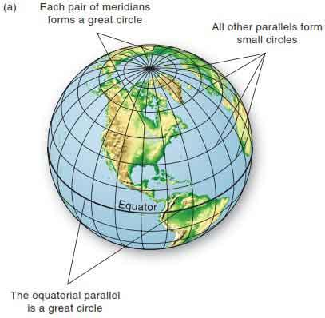
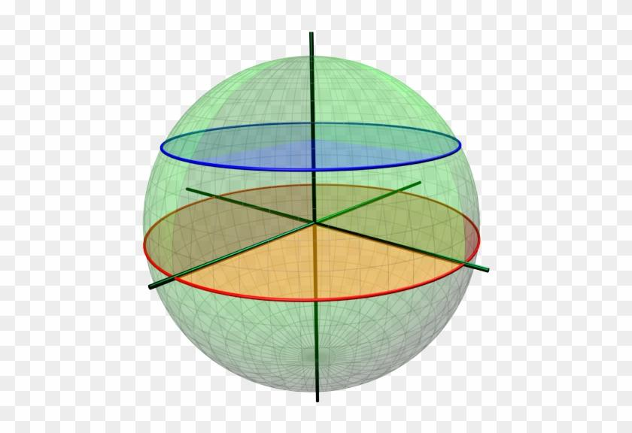
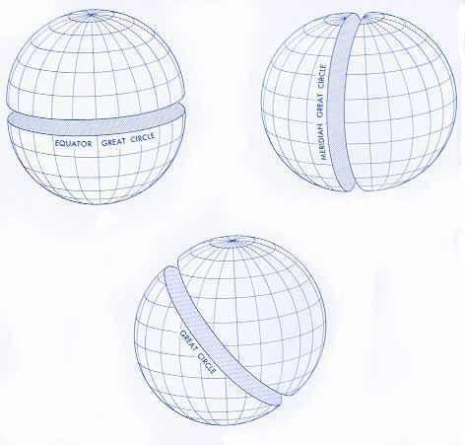
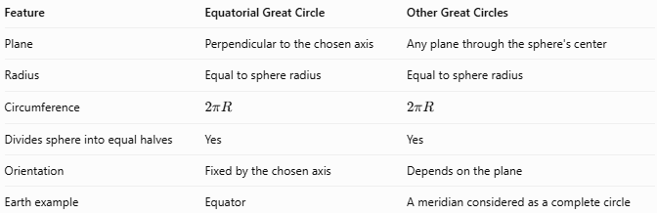
Feature | Equatorial Great Circle | Other Great Circles
Plane | Perpendicular to the chosen axis | Any plane through the sphere's center
Radius | Equal to sphere radius | Equal to sphere radius
Circumference | $$2πR$$ | $$2πR$$
Divides sphere into equal halves | Yes | Yes
Orientation | Fixed by the chosen axis | Depends on the plane
Earth example | Equator | A meridian considered as a complete circle
A complete meridian, together with its opposite meridian, forms a great circle through Earth's poles. Each such great circle has the same circumference as the Equator.

Applications
# Source: AI Source: Provided by: [Data Path: Persons Table -> ID Column: 1, Name_En Column: Motasem Essam] -> From: [ChatGPT] on [7/25/2026]
- Geography: Dividing Earth into the Northern and Southern Hemispheres.
- Astronomy: Defining equatorial reference planes for celestial coordinate systems.
- Navigation: Providing a reference for latitude and spherical positioning.
- Mathematics: Studying planes, circles, and symmetry on spheres.
- Planetary science: Comparing equatorial dimensions and orientations of spherical bodies.

Key Points
# Source: AI Source: Provided by: [Data Path: Persons Table -> ID Column: 1, Name_En Column: Motasem Essam] -> From: [ChatGPT] on [7/25/2026]
- An equatorial great circle is a great circle perpendicular to a chosen axis.
- Its plane passes through the sphere's center.
- Its radius is the same as the sphere's radius.
- It divides the sphere into two equal hemispheres.
- Earth's Equator is the familiar example.
- Every great circle on the same sphere has the same circumference.

Conclusion
# Source: AI Source: Provided by: [Data Path: Persons Table -> ID Column: 1, Name_En Column: Motasem Essam] -> From: [ChatGPT] on [7/25/2026]
The equatorial great circle is a special great circle defined by a sphere's chosen axis of rotation or reference axis. Its plane passes through the sphere's center and is perpendicular to that axis. Like every great circle, it has the maximum possible circular radius on the sphere and divides the sphere into two equal halves. On Earth, the Equator serves as the fundamental reference for distinguishing the Northern and Southern Hemispheres.

